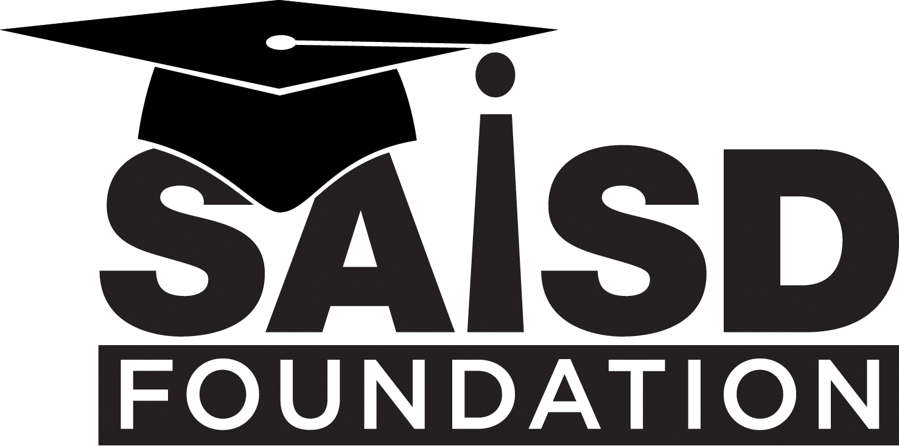

SAISD & SAWS 5K FOR EDUCATION
March 3, 2018 - Sponsorship Levels & Benefits

Gold Medal/Title Sponsors $5,000
- Blue Ribbon Sponsor benefits**
- Large sponsor logo on 4,000 event shirts
- Logo prominently displayed on race start/finish banner
- Race day announcement from sponsor representative and race announcer
- Logo on Alamo Stadium Scoreboard Screen at event
- Four School Sponsorships (10 race entries for 4 schools & 10 for you)

Blue Ribbon Sponsors $3,000
- Red Ribbon Sponsor benefits
- Logo displayed on signage at race start/finish tower
- Sponsor logo on school posters and social media**
- Race day announcement by race announcer
- Logo on Alamo Stadium Scoreboard Screen at event
- Three School Sponsorships (10 race entries for 3 schools & 5 for you)

Red Ribbon Sponsors $2,000
- White Ribbon Sponsor benefits
- Sponsor logo on website and event shirts
- Two School Sponsorships (10 race entries for 2 schools)

White Ribbon/Mile Marker Sponsors $1,000
- School Sponsor benefits
- Vendor table at Health Festival
- One School Sponsorship (10 race entries for one school)

School Sponsors $500
- Sponsor name printed on 4,000 event shirts*
- Sponsor name listed online
- One School Sponsorship (10 race entries for one SAISD school)

In addition to your Sponsorship, the following may be added for $100 each:
- Purchase race entries for 10 SAISD students
- Purchase race entries for 5 students, a parent and an administrator

All Sponsorship levels include the benefits of the sponsor levels below it.
*1/26/18 Shirt Print Deadline **1/2/18 School Poster Deadline

Your sponsorship helps us continue… Making Strides in Education

In 2017, over 4,200 people registered for this growing, family-friendly event. The SAISD Foundation 5K has served as a catalyst to start running clubs and health & wellness clubs and activities at multiple schools in San Antonio ISD. Help us continue to support this energy toward greater fitness and the development of life-long healthy habits by sponsoring this event. Funds raised also support campus-based Mini-Grants. This school year, we have already received 190 Mini-Grant applications with innovative ideas in STEM, Fine Arts, & Enrichment …Ideas that are igniting passion for student success!

