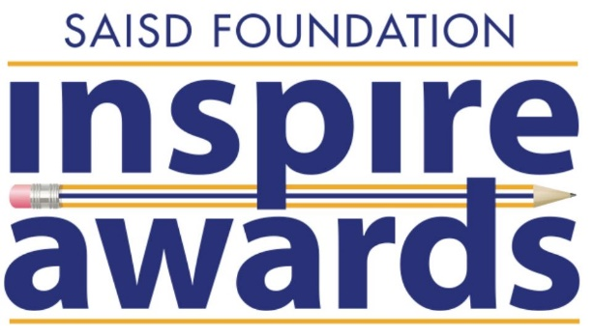

The Inspire Awards hopes to inspire SAISD students with the stories of those who have once walked the very halls they do now, showcasing the talent that comes from SAISD schools through these awards to distinguished SAISD alumni and organizations that help make our work possible.

**2021**

Suzanne Scott

Catherine Torres-Stahl

Boone Powell

**2019**

Yvonne “Bonnie” Garcia

Diego Bernal

Cosmo Guido

Paula Gold-Williams

**2018**

Charles T. Barrett, Jr.

Robert Chavez

Marcia Nasatir

Belle San Miguel Ortiz

**2017**

Roy Barrera, Sr.

Jim Lehrer

Dr. Maria Hernandez Ferrier

**2016**

Dr. Jaime Garza

Dr. W.E. Moerner

Lionel Sosa

**2015**

Alma L. López Cavazos

Miller Family of Bill Miller Bar-B-Q

John Quiñones